8086 Clocks & Timing Diagrams
Dept. of Computer Science and Engineering

Fetch
Decode
Execute
- An instruction e.g. MOV [7531h], AX ; SUB CH, [0ABCh] etc
- The time a µP requires to complete fetch-(decode)-execute
operation of a single instruction is known as Instruction

Cycle

- Instruction Cycle consists of one or more Machine Cycles
- A basic µP operation such as reading/writing a byte from or
to memory or I/O port is called a Machine/Bus cycle

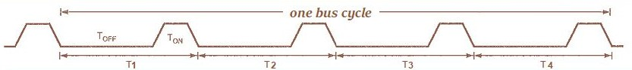

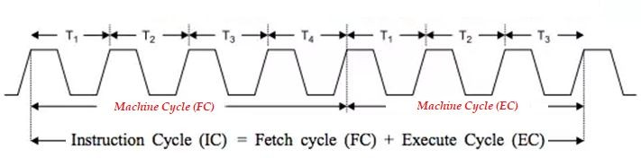

  - A Machine (bus) cycle consists of at least four clock cycles, called T states.
  - One cycle of a clock is called a State
  - Each read or write operation takes 1 bus cycle.

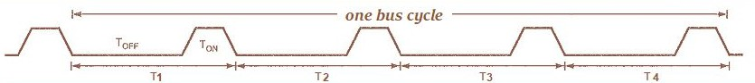

Clock Generation
  - Clock generator circuit is 8284A and connected to pin 19 (CLK) of 8086.

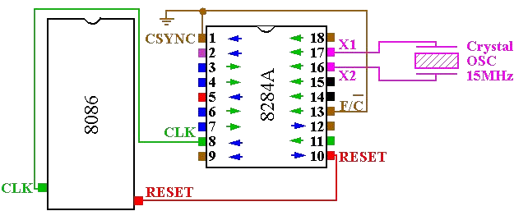

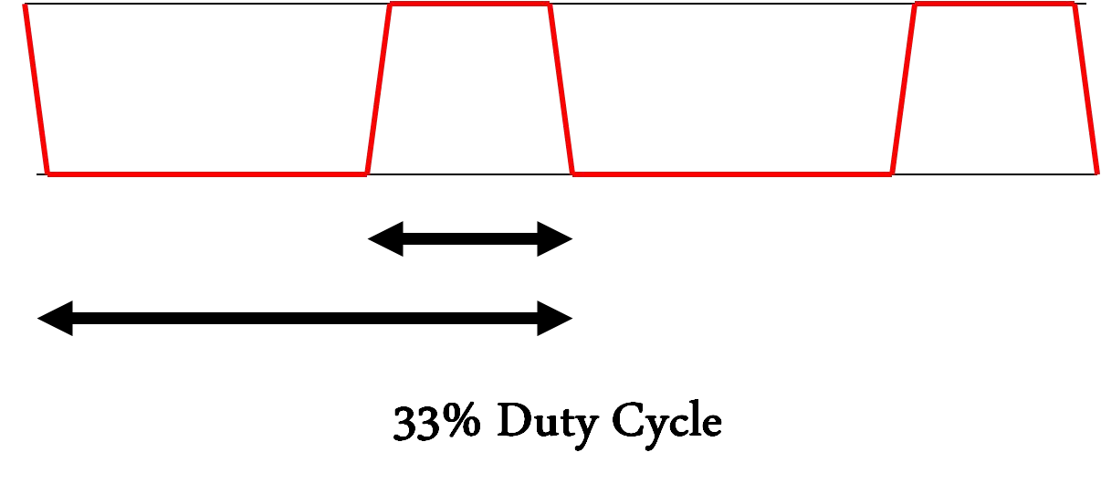


System Clock Concept
- 8086 is found to operate in between 5 to 10 Mhz.

- An 8086 running at 5MHz, its clock pulses will be of 200ns and it would take 800ns for a complete bus cycle.

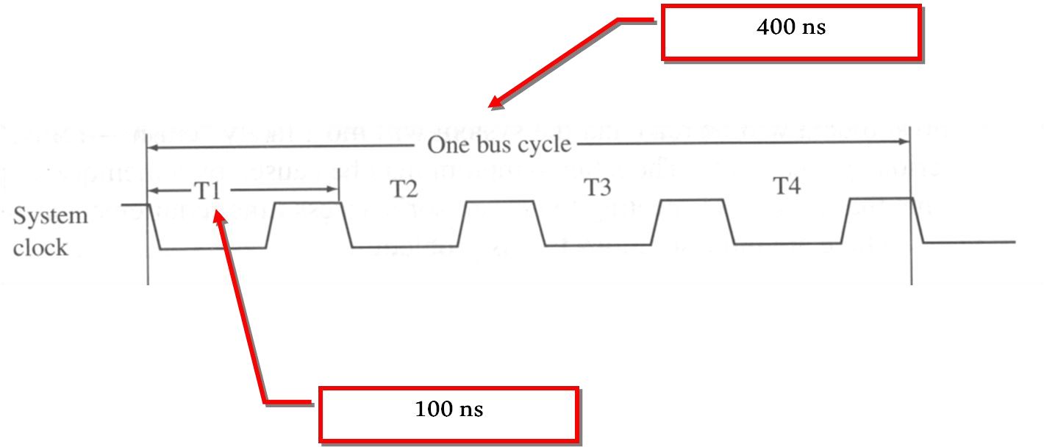
For a 10MHz 8086, its clock pulses will be of 100ns and it would take 400ns for a complete bus cycle.

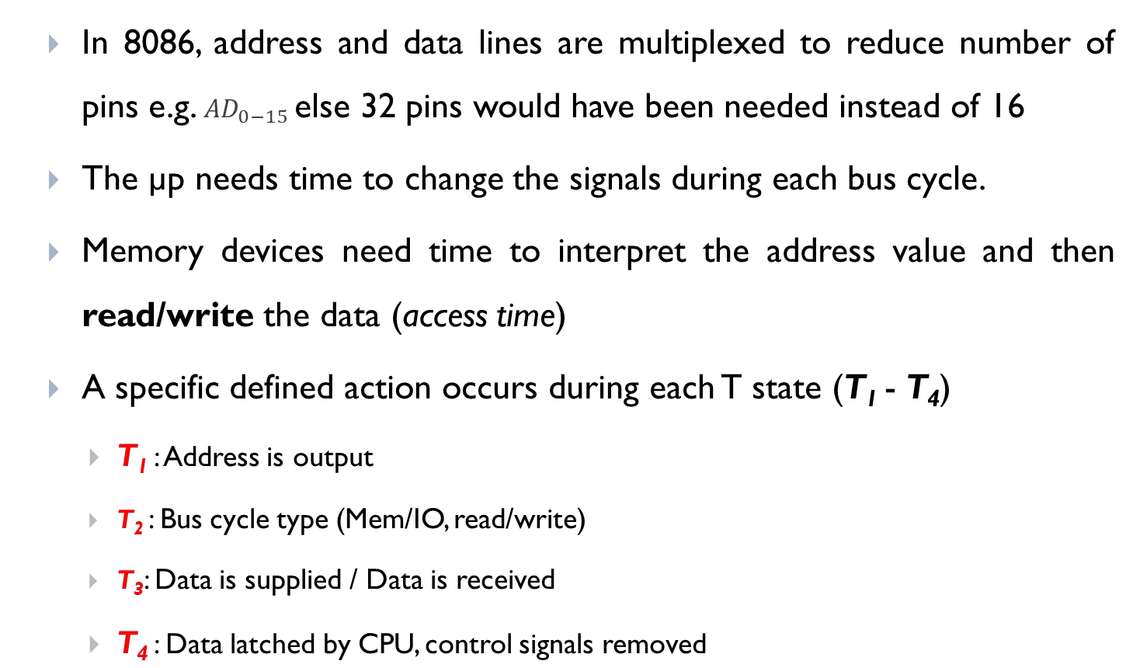
Clock States - Why are there T states?
□

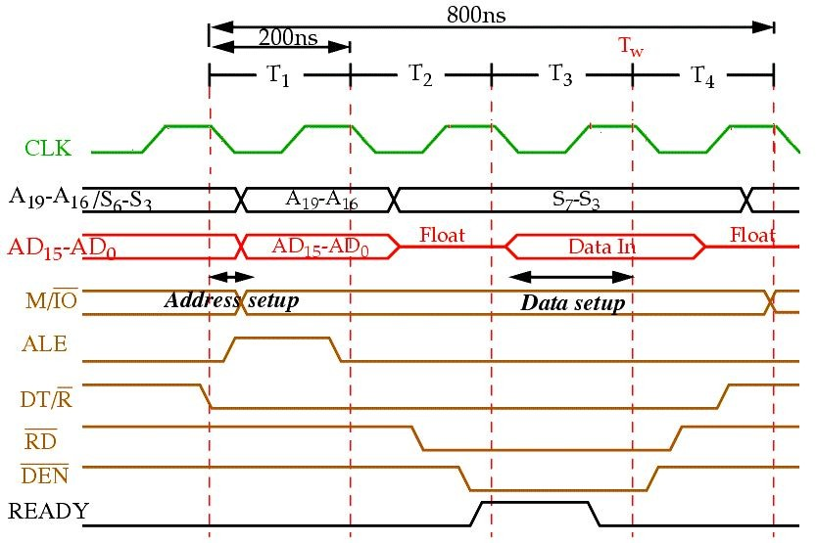
Address of memory is sent out by 8086 via address bus Used Control signals: ALE, DT/R’, M/IO’ shows some output


8086 issues either RD’ or WR’ and DEN’
In case of WRITE (WR) operation, data to be written appear on data bus

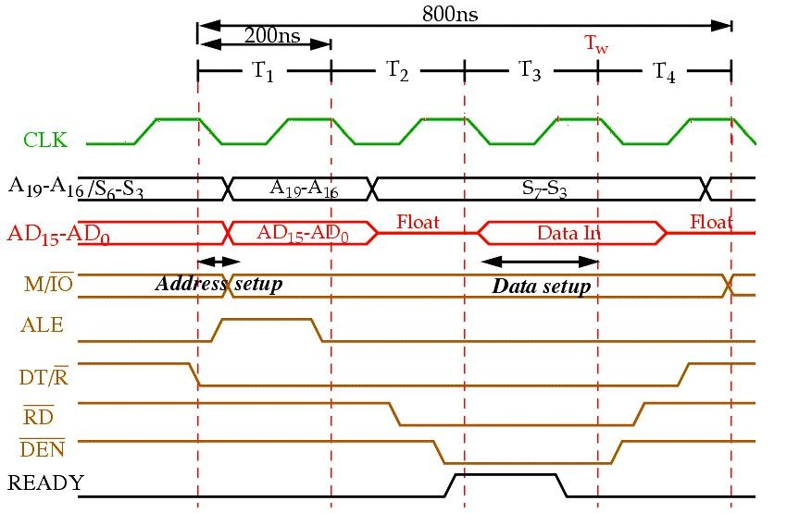
READY is sampled at the end of T2
If READY is low,T3 becomes a wait state (Tw), means no operation (NOP).
In READ bus cycle data bus is sampled at end of T3


All bus signals deactivated in preparation for next bus cycle µP sampled data bus for data that read from M or I/O

- A specific, defined action occurs during each T states (T₁ – T₄)
- T₁: Address is output
  - Address of memory is sent out by 8086 via address bus
  - Used Control signals: ALE, DT/R’, M/IO’ shows some output
- T₂: Bus cycle type (MEMORY/IO, READ/WRITE)
  - 8086 issues either RD’ or WR’ and DEN’
  - In case of WRITE (WR) operation, data to be written appear on data bus

- T₃: Data is supplied
  - READY is sampled at the end of T₂
    - If READY is low,T₃ becomes a wait state (Tw), means no operation (NOP).
    - In READ bus cycle data bus is sampled at end of T₃
- T₄: Data latched by µP, control signals removed
  - All bus signals deactivated in preparation for next bus cycle
  - µP sampled data bus for data that read from M or I/O
  - At trailing edge of WR’, transfer data to M or I/O

8086 Ready pin

- The READY input is controlled to insert “Wait states” into the timing of the microprocessor for slower memory and I/O components..
- If the READY pin is at a logic 0 level, the micro-processor enters into wait states and remains idle.
- When it is high (logic 1), it indicates that the device is ready to transfer data.
- A wait state is a situation in which a computer processor is waiting for the completion of some event before resuming activity.
- A program or process in a wait state is inactive for the duration of the
wait state.

Ready pin and Wait state

  - When a computer processor works at a faster clock speed than the random access memory ( RAM ) that sends it instructions, it is set to go into a wait state for one or more clock cycles so that it is synchronized with RAM speed. In general, the more time a processor spends in wait states, the slower the performance of that processor.
  - Wait states are a pure waste for a processor's performance. Modern designs try to eliminate or hide them using a variety of techniques: CPU caches, instruction pipelines, instruction prefetch, simultaneous multithreading and others.

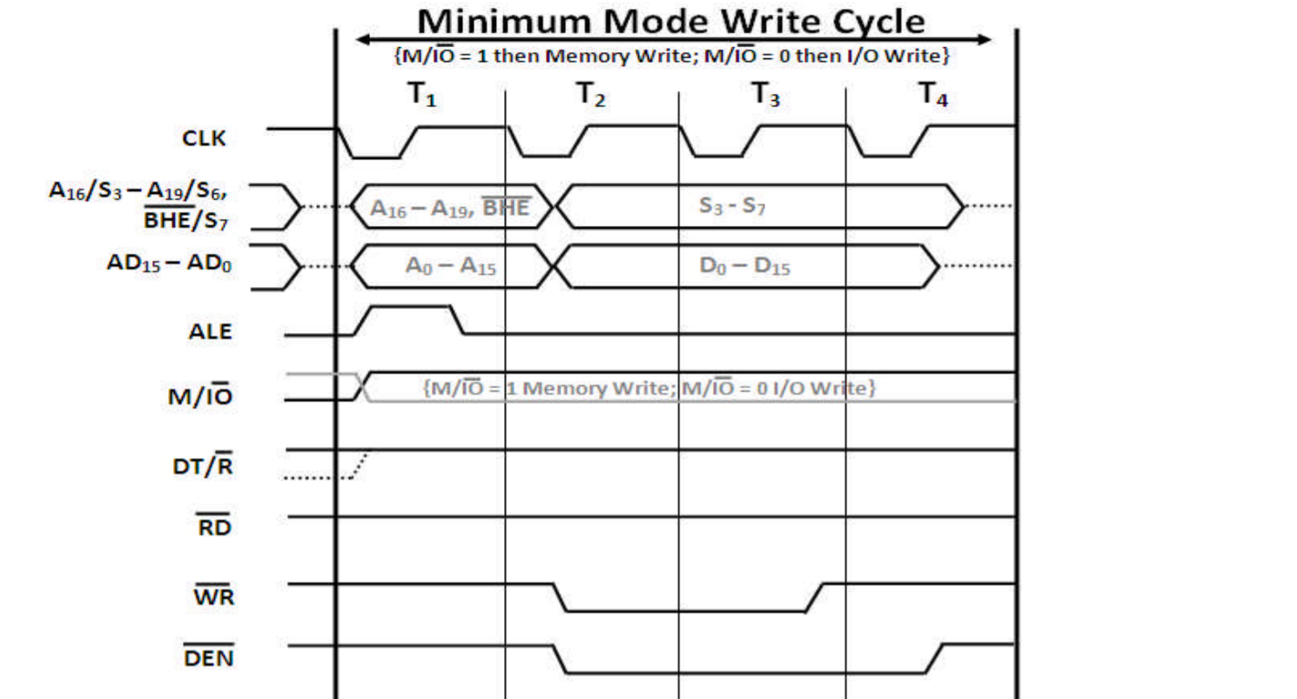

Thank You
Questions are welcome in the
discussion class

